Thirteenth Annual
Residents’ Rights Rally
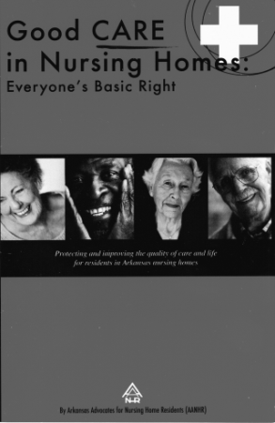
Please Join Us!!!
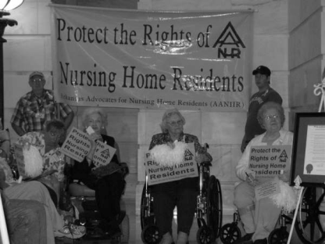
Monday, October 10th, 2016

AR State Capitol steps 11:00 AM
Rotunda

Keynote Speaker:
Arkansas Attorney General
Leslie Rutledge

Hosted By
Arkansas Advocates for Nursing Home Residents
www.aanhr.org

For more info please call 501-450-9619 or 501-269-4626

Program of Events:
Martha Deaver, AANHR President………………………..…..………………Welcome

Dr. Gerald Parker Sr., Pilgrim Progress Missionary Baptist…..…Invocation

Martha Deaver, Event Chairman……….………….Proclamation Presentation

Leslie Rutledge (Keynote Speaker)………………………..AR Attorney General

Col. Matt Snead………………………………………..………………………..ADVA Director

Jennifer James………..……………………………………….….AR State Ombudsman

Dr. David Montague………………..….Director of UALR Senior Justice Center

Martha Deaver……………………………………….………………………..Closing Remarks

October is National Long-Term Care Residents’ Rights Month

“Speak up for those who cannot speak for themselves, for the rights of all who are destitute. Speak up and judge fairly, defend the rights of the poor and needy.”
Proverbs 31:8 NIV

